# France: A Costly Mistake. Germany: A Dream Come True.

I was very sad to leave Thun, Switzerland. It felt like a little bit of home away from home there. I loved the mountains, the clear and crisp air, the people, and how clean everything was. I loved the magic of the castle sitting in the middle of all the hustle and bustle, and the large lake with its sparkling water just beckoning for everyone to come and see.

I loved learning about my Mennonite (Anabaptist) heritage. I even learned that some of them had been imprisoned in the Thun Castle! (Joder or Yoder was their name)

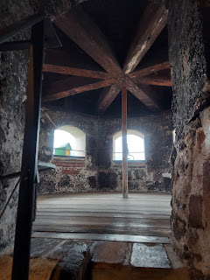

You can read more by clicking on this link. (*Dad*)

https://www.menno.ch/wp-content/uploads/2021/01/Taeuferfuehrer_engl_2018_compressed.pdf

pg 54-55

Monday:

I got on a train to go from Thun to Bern to Zurich to Hombrechtikon. I managed to make all the connections just fine. Once I got to Hombrechtikon, I got on a bus to get a little closer to my AirBnb, and then I walked the last little bit.

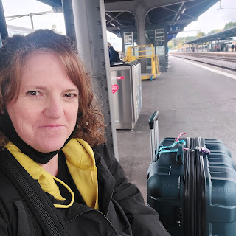

I passed Lake Zurich on the way to Hombrechtikon.

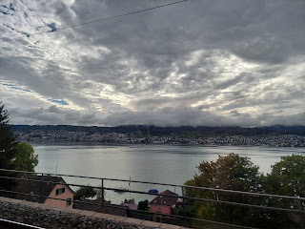

The train makes several stops, so it is very helpful to watch for my stop on a screen. I was watching for the Feldbach stop.

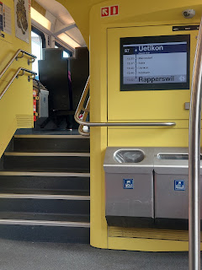

On the bus through town, I saw my family name on a store front! Dandliker. This was a store selling RV's, which I thought was interesting because I hadn't pictured people driving RV's across Europe. :)

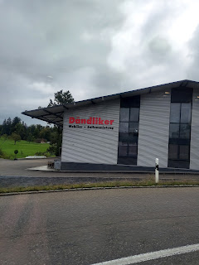

After I got off the bus and started walking, I got a little mixed up while using Google maps on my phone, not knowing which apartment building was the correct one, so a quick call to my host fixed that. She could see me across the street from her balcony window, and waved to me so I could locate her, ha ha. We hauled my suitcase up a few flights of stairs, and then I could finally rest for a bit.

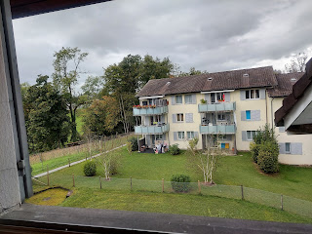

Maryam, my host, is originally from Iran. She has lived in many places, including Portugal, before settling in Switzerland. She spoke very good English, and was a very calming personality. She follows the teachings of the Dalai Lama and has a spiritual master, she does yoga, and she does meditation classes through Zoom. She offered to make me dinner, which I readily accepted after the busyness of the day. She made me chicken, vegetables, and a salad. It was very tasty!

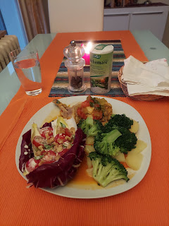

Hombrechtikon is right in the heart of where my Mennonite ancestors lived in the 1600s. Dandlikon and Feldbach are connected to Hombrechtikon, although on the outskirts. It is all very rural and, with a smaller population, the best way to get around is to just walk. Yes, there is a bus system, but it takes a while for it to come back around to pick you up at a particular stop. You're better off to just walk and get there faster, ha ha.

Tuesday:

I got up and got ready quickly so that I could put in a full day of walking to get to everywhere I wanted to go. The weather was cooperative, for the most part, only sprinkling here and there while I was out and about.

Here are some of the views as I walked to Dandlikon.

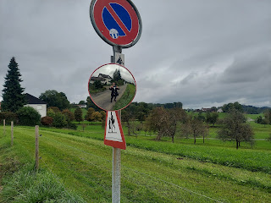

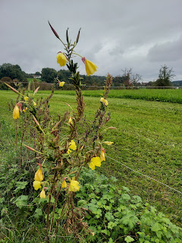

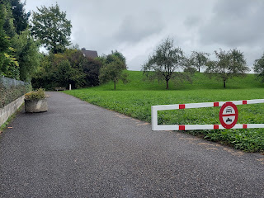

Sometimes I would be walking through a neighborhood, but most of the time I was just out in the country.

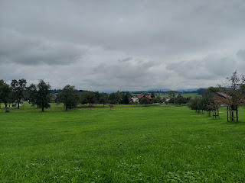

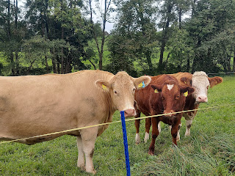

A Swiss milk cow. I wondered if her name was Bessie.

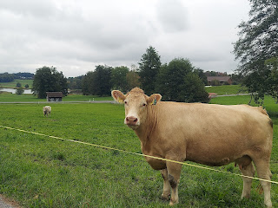

A gourd stand sitting by the road.

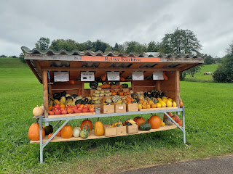

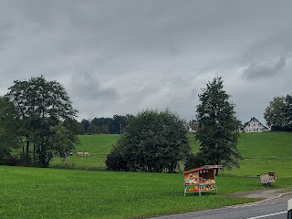

Some of the trees are starting to shed over here. Some are just barely turning colors, though, too.

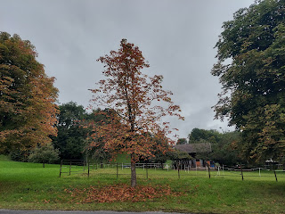

Finally, I reached the intersection of Dandlikerstrasse. This road would lead me to the "heart" of Dandlikon.

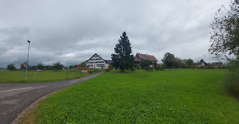

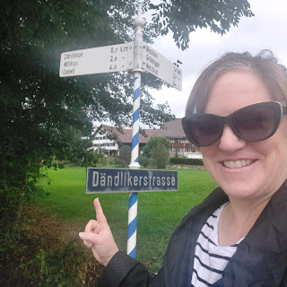

But first, I needed to take a little detour across the road to see the sheepies.

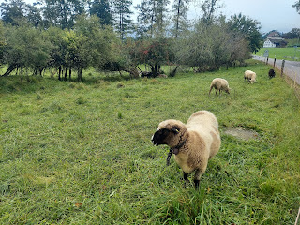

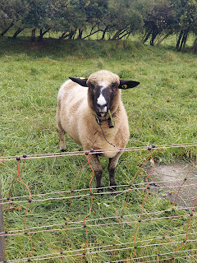

They all wear little bells around their necks, just like the cows. It was fun to just listen to their bells as they munched the grass.

Video of the sheep: (28 seconds)

https://photos.app.goo.gl/ts29YwxSQtxM1YCRA

Now, on to Dandlikon.

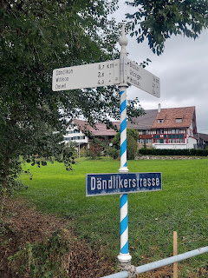

I was even impressed with how neat and tidy their woodpiles are in Switzerland! Everything they do is very beautiful and precise.

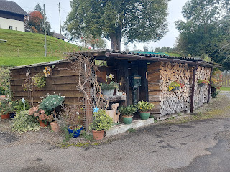

I loved the open fields along Dandlikerstrasse (which just means Dandliker Street).

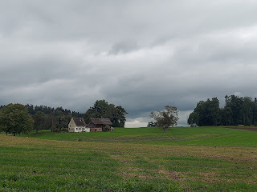

And I imagined my family, or perhaps even their neighbors, living in these houses long ago.

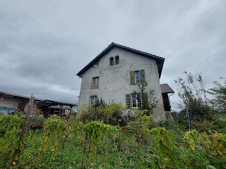

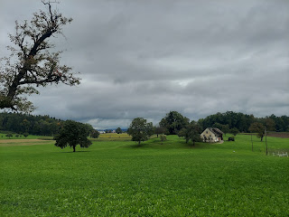

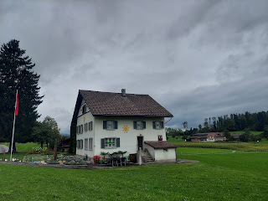

The "heart" of Dandlikon is this intersection. It shows on the street sign that this is what used to be the town center.

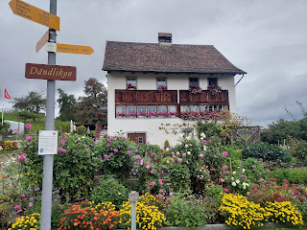

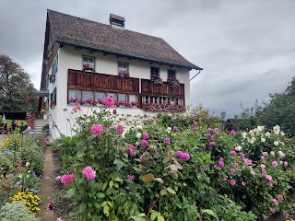

And on the street sign, at the very bottom, it mentions my family name of Dandliker. (The American derivative became Denlinger) My AirBnB host helped me translate what it says on the sign. The gist of it is this: You can find the family name Dandliker in the Hombrechtikon/Feldbach telephone book (from 2007), where the name is listed about 16 times.

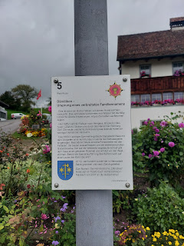

Here is a short video of me walking along Dandlikerstrasse. (34 seconds)

https://photos.app.goo.gl/DcqA3DdojTzPyF5q7

From there, I turned toward Hombrechtikon again. (It was approximately a 28 minute walk to get out to Dandlikon)

As I came into town, I could see the old church above the cornfields.

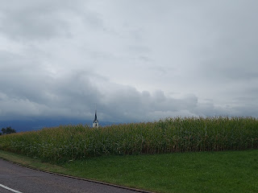

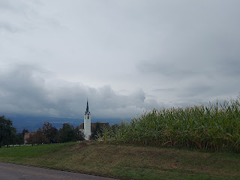

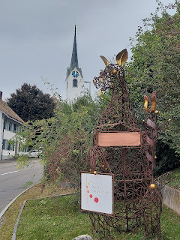

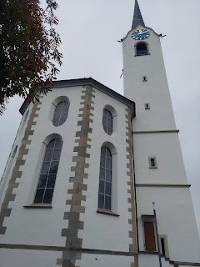

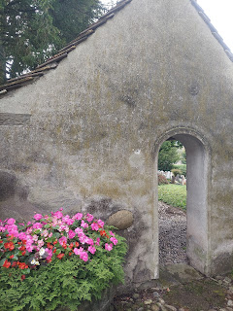

As I followed the pathway around to the back of the church, I saw an old cemetery there. Again, in Switzerland, everything they do is just gorgeous!

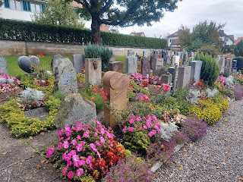

I learned in my research that in Switzerland they only keep the plots for 25 years. Then they dig up the bodies and make room for the new. It is strange, and even horrible to think about digging up your loved ones, but they try to make the best use of space. I suppose in some way, it is simple for me to imagine that my ancestors could have been buried in this exact spot hundreds of years ago.

I did find a few current day Dandlikers buried in this quaint little cemetery.

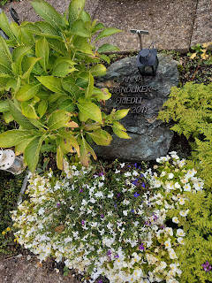

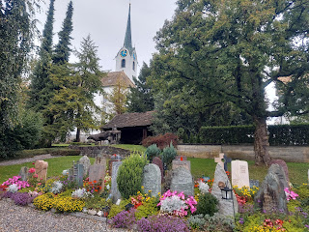

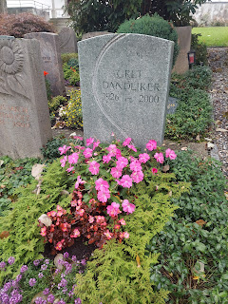

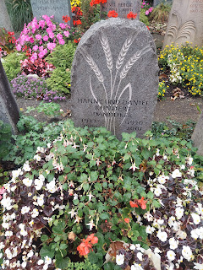

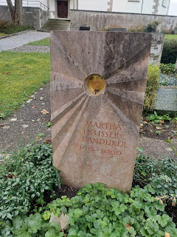

After I was done enjoying the charming little cemetery, it was time to go find some lunch.

I found a little restaurant nearby, where I ordered some soup, salad, and pizza.

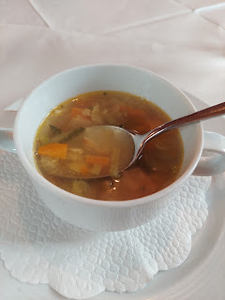

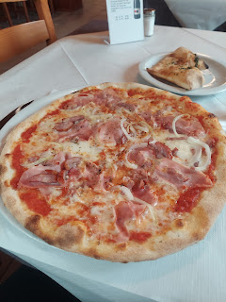

The menu was difficult at times in Switzerland - it didn't always have English subtitles ha ha. I have used the Google Translate app on my phone often, to put something in for translation. In this case, I learned what the soup actually was! And it was delicious by the way!



I went to a Swiss grocery store so I could find some Swiss chocolate. And boy, did I hit the jackpot! This entire aisle was filled with chocolates!

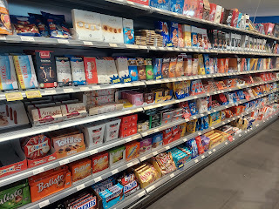

Lots and lots and lots of cheeses and dairy items to choose from.

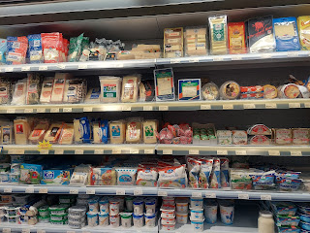

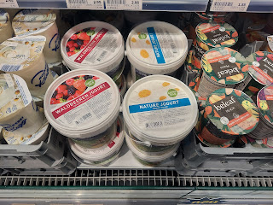

I thought it was strange, yet interesting, that they keep the eggs on a shelf instead of in a refrigerated area. And the colors of the eggs! Wow - so very fancy!

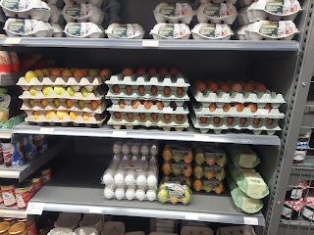

Lots of colors of saur kraut.

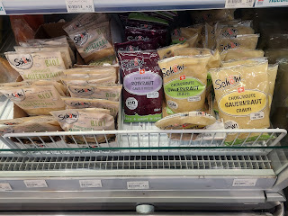

Meat is plentiful and there is a wide variety to choose from.

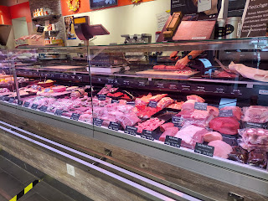

And even more cheeses!

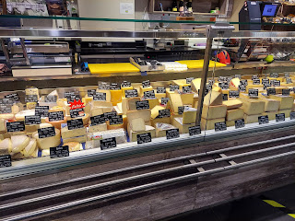

Even the frozen spinach and frozen peas had interesting names!

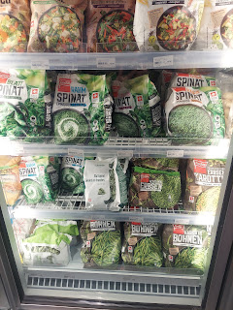

Once I had made my selections and paid for them (in Swiss Francs), I made my way over to the local post office so I could mail home some chocolates. :)

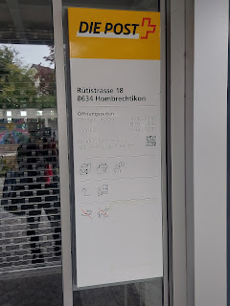

I thought some of the street names were quite entertaining. Imagine if I didn't have Google maps to guide me everywhere. Could you know where to go by reading these signs?

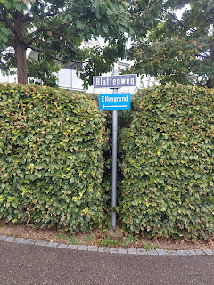

I enjoyed a great conversation with Scott after I got back to my room to rest for a bit. He is plugging along without me, and seems to be doing okay. He doesn't

really

know how hard it was for me to have him gone so many times over the years - and for such long periods too!

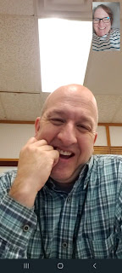

I went on one last adventure in Hombrechtikon. I wanted to go down to Feldbach and walk out to Lake Zurich. It was relatively close, and I wanted to make the effort while I was there.

On my way, I saw a very interesting type of goat.

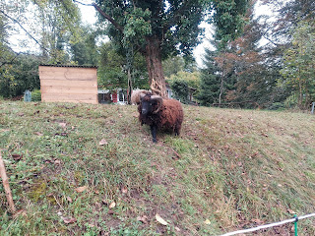

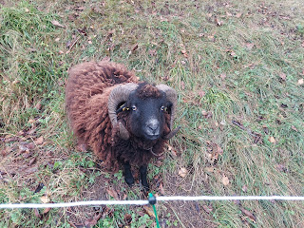

You can watch a short video of him here: (20 seconds)

https://photos.app.goo.gl/sw93jLYs19vNRioB7

Continuing on my walk into town, I was appreciative of all the nature surrounding me.

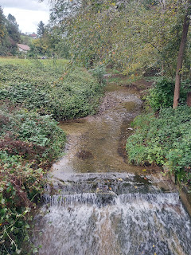

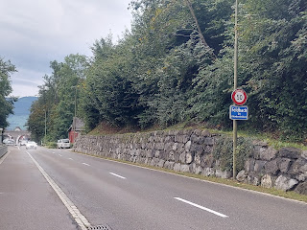

This is the heart of Feldbach.

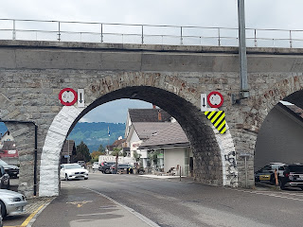

There is a little lane, one of many ways to get down to the Lake, but this one I thought was very scenic.

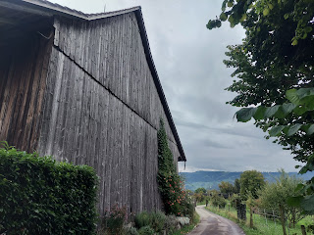

There are lots of vineyards everywhere, and apple orchards as well.

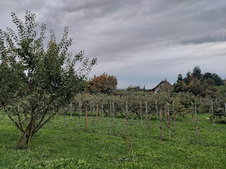

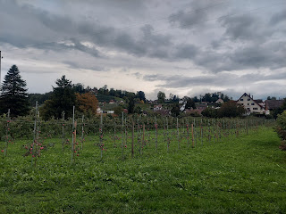

The huge cowbells are comical and delightful at the same time. I love listening to the cows and their huge bells as they munch on the grass and move about.

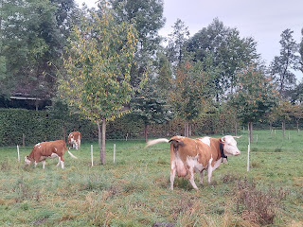

Click here to listen to them: (27 seconds)

https://photos.app.goo.gl/H3VgLpnwebuLMNFm9

Lake Zurich

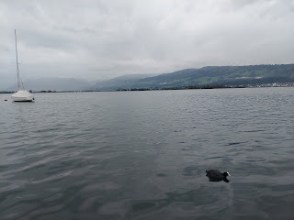

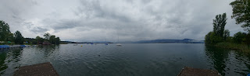

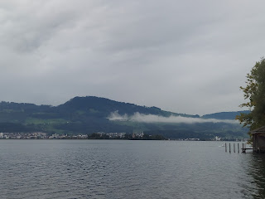

Video of the ducks along with the quiet and calmness of the lake: (1 min, 5 sec)

https://photos.app.goo.gl/4o21iEPBN8kS2Xnu7

I loved seeing a sprinkling of fall colors, with a town such as Feldbach as the backdrop.

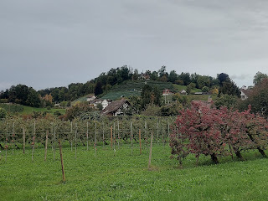

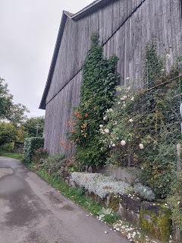

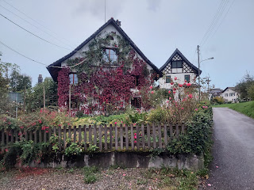

By the time I got back to my room and got into my pajamas for the night, I had walked approximately 8.25 miles that day. Wowza!

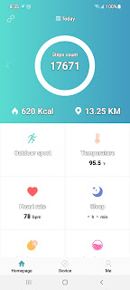

Wednesday:

I had to say goodbye to Switzerland and travel to Strasbourg, France. I was most nervous and anxious about going to France for some reason. I think it was because I am uncomfortable with speaking French, and can't do it very well, plus the French are notorious for being snobby and rude if you can't speak their language while you're staying in their country. Experts say that you must always say "Bon Jour" to everyone in every circumstance, even if you cannot say anything past that. If you at least greet a French person in their native tongue, then any botched attempt to communicate past that point will be taken more affably.

This made me very nervous. Plus, even though I had prepared for many months for this trip, there were still so many details that were not resolved yet, and France was a big worry in the pit of my stomach.

And yet, the show must go on. I could not stop now! There was a recent quote in a church conference talk that says: I did not come this far, only to come this far. How true this was at this very moment!

I made all of my connecting trains for the day, from Feldbach to Zurich, Zurich to Basel, and Basel to Strasbourg.

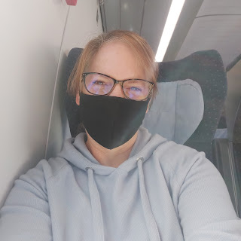

Along the way, I saw a huge Lindt chocolate factory. Hooray for chocolate!

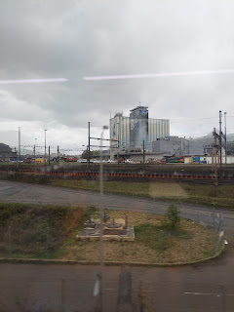

I also saw several more beautiful fields that reminded me of home.

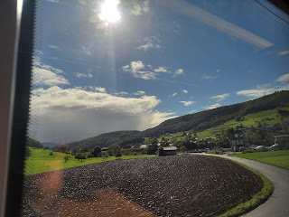

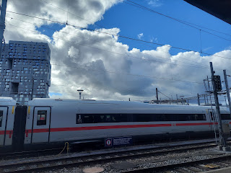

Eventually I made it to Strasbourg, France. After I found a bus to take me closer to my AirBnB, I was rewarded with this lovely view from my window. It is the Cathedral of Strasbourg, built in 1439.

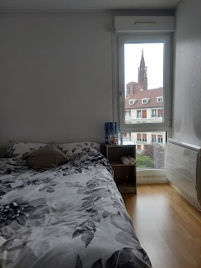

After I laid down to rest for a little bit, due to all the train travels, I was ready to go on a walk. I was on a quest to find a crepe and a galette while in France. My sister, Charmaine, and I had eaten some of the most amazing crepes and galettes when we visited France in 2018 together. I have never forgotten them!

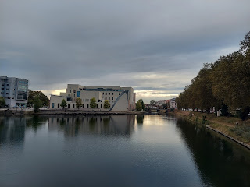

An 18 minute walk to a restaurant that I found on Google took me over the river on a series of pedestrian bridges.

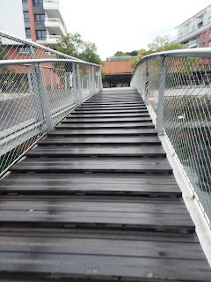

There were some beautiful swans lazily diving for food in the river as I passed by.

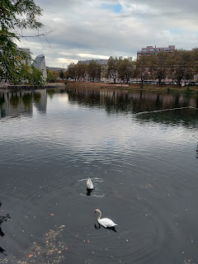

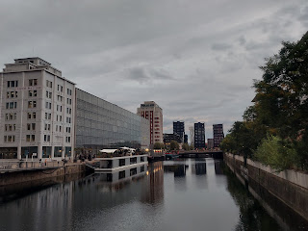

What I didn't know when I chose this restaurant on Google is that it was in a MALL! It had great reviews, so I decided to give it a try.

What I was trying to recreate in my mind was the same salmon and cream galette that I had 3 years ago. So I ordered the one on the menu called Nordique, listed with salmon and a few other things.

It was just "meh". But the sweeter crepe that I ordered to take with me was delicious! It had a sprinkling of sugar and some lemon juice, thus making it a "citron" crepe. :) As the young man prepared it right in front of me, we struck up a conversation in English. He is from France, but his dream is to go to Chicago in the U.S.!! Not sure why he's set on Chicago, but he is hoping to make it there someday. He was very friendly and really helped me feel welcome in a huge and unfamiliar city.

Since I was already in a MALL - I decided to browse around and see if I could find a cute outfit for Jack-Jack. While I found many handsome potentials, I decided against buying any of them. Mainly because his parents worry that with Jack's wide girth currently, it's hard to find a 2-piece outfit (shirt or onesie, plus pants) that fit him very well. In order to accommodate his cute and big belly, you have to choose a larger size pair of pants. But then the pant legs are way too long, and they have to roll them up several times. It's better to find a romper if possible. But no rompers in the French mall. So I left empty-handed.

As I settled down to go to bed, this was the view out my window.

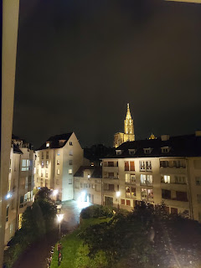

Thursday:

I had prepared and researched as best as I could the night before for this very day. This was the day that I would be renting a CAR in France for the day! I had watched several YouTube videos with driving tips for France, I had refreshed on what the street signs meant, and I had reviewed my rental contract. Now it was time to be brave and just do what I came to do.

I took the bus over to where the car rental office was, near the Strasbourg train station. Thankfully the lady inside spoke reasonably good English and we could communicate effectively. Soon enough, I was in a Kia driving through France on my way to Ibersheim, Germany!!

All my anxiety calmed down as I drove out of the city and onto the highway headed north. The landscape was amazing and I wished SO MANY TIMES that I was a passenger and could take a bunch of pictures. Instead, I had to be responsible and just drive the car, ha ha.

I arrived at noon in Ibersheim with no issues of any kind and found a place to park my car. I saw the church off in the distance, when almost immediately the bell began to chime!

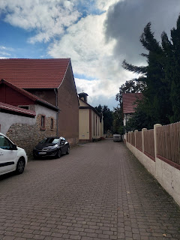

Video of the church bell ringing as I walked toward it: (17 seconds)

https://photos.app.goo.gl/cKLH2zL8k8HgvjnE8

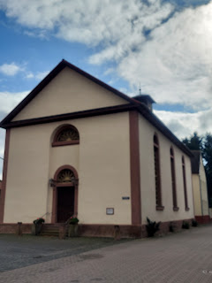

The significance of Ibersheim, Germany is that my Mennonite ancestors fled Switzerland because of the heavy persecution, and ended up here. After the 30 Years War, the King was happy to lease the ravaged land to an industrious people, known for their hard work ethic and farming capabilities. He knew that this would be good for his country. So my people settled here for a time. (Surnames: Denlinger (Dandliker/Dentlinger), Yoder, Hockman and Funk)

Per Wikipedia: (re: Ibersheim, Germany)

In spring of 1661, there was a major wave of economic and religious refugees from Switzerland's Zürich region, whom the Elector allowed to settle in the region.

In 1671, a mass emigration of Mennonites from the Bern region occurred. Of all the Mennonites worldwide, around 10% originate in this region.

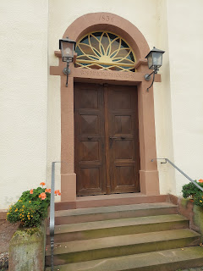

While this is not the original church (1836), it was built on the

original site

where the old Mennonite Church once was. And that made it very special.

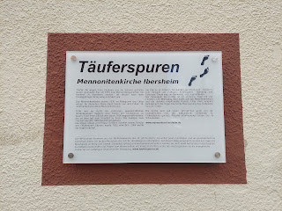

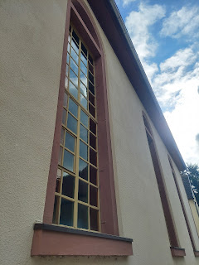

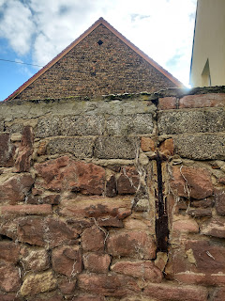

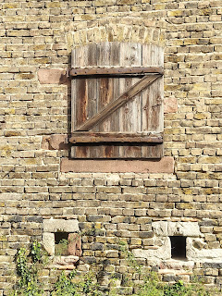

After walking all the way around the church, I began to wander the old and narrow streets nearby.

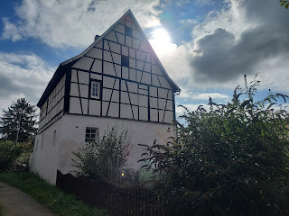

Kirchplatz basically means Church Place. Or Church Street.

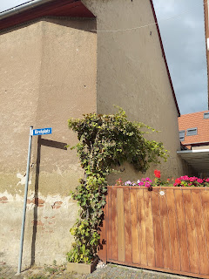

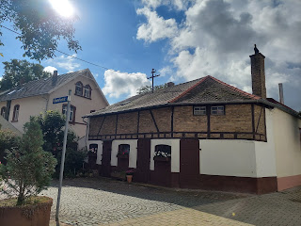

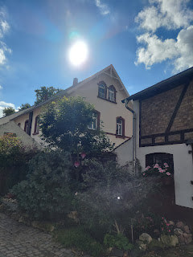

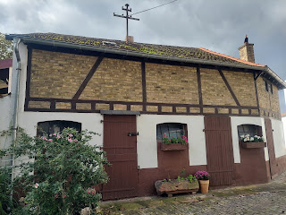

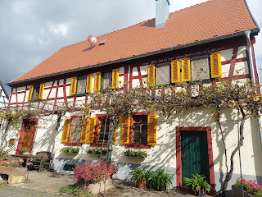

At one point, as I wandered the seemingly vacant streets, I came across an elderly man out working in his shop. I asked him in German if he spoke English, to which he replied "very little". He really meant it, too! I tried to explain to him why I was in the area and wanted to know if he knew any families of those surnames today. I even tried to use my Google Translate app on my phone to help guide our limited conversation, as well as drawing him words and pictures on my notepad. But it wasn't working, ha ha. His wife popped into the window of their house across the street, and she spoke a few more words of English, but I just had to settle for the fact that I wasn't going to meet any current-day relatives in Ibersheim. At least not this day. But they were friendly and really tried their best, and I appreciate that very much.

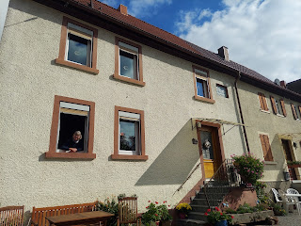

I continued walking around, admiring all the unique features of an old German village.

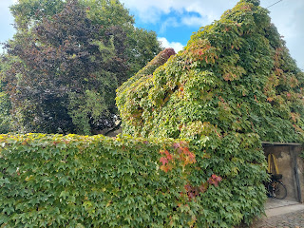

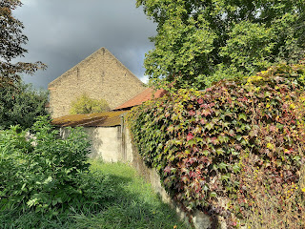

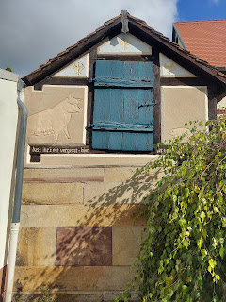

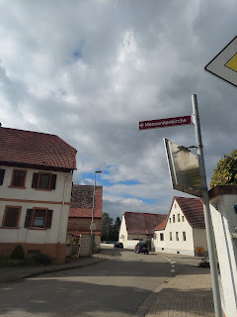

All I had for breakfast that day was an apple, so I was starving by this point. And my bladder was uncomfortably full as well. So I reluctantly got into my car to leave little Ibersheim, and find civilization to the south in Worms. Right away, I found the outskirts of Ibersheim, with a beautiful field and a SIGN!!

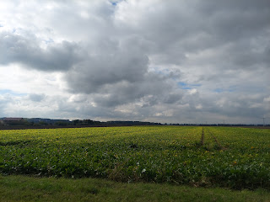

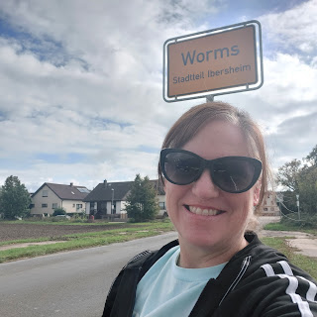

I had also noted the Rhine River as I drove into Ibersheim, promising myself to find a place to pull over and walk down to the water on my way back.

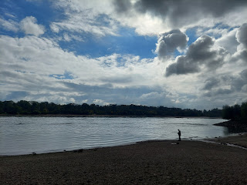

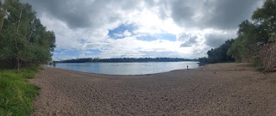

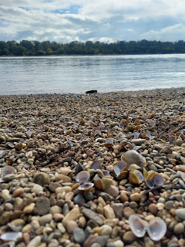

I found a small town close to Worms that had something to eat. I was willing to eat just about anything at this point - even German bread! (watching the carbs you know)

I chose a cheesy bread, which turned out to have some sort of pimento mix in the filling, and it wasn't that bad!

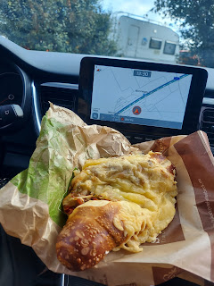

And I couldn't resist choosing a dessert at the same time. This was sort of like a cinnamon roll. It was a little more dry, and instead of the brown stuff being cinnamon, it was more like a vanilla flavor. But it was good. I only ate about half of each one.

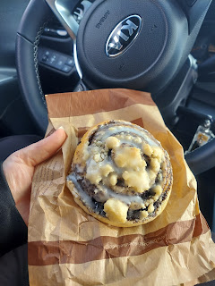

In Germany, they have the occasional rest stops along the highways. This is where I finally found a bathroom. My neighbor back home, Helma, had warned me though to always have some change handy for using the bathrooms in Europe. I paid 0,70 euros to use the public restroom. (= 80 cents in USD)

Once you pay, then you can actually enter. Keep in mind: the money pays for the upkeep of the bathroom, which is something we all wish for when we travel. Right?? (toilet paper, cleaning service, etc.)

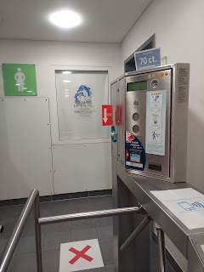

I saw vineyards everywhere on my drive. I just wish I could have taken more photos of how beautiful they truly were. This just happened to be next to the rest stop where I was.

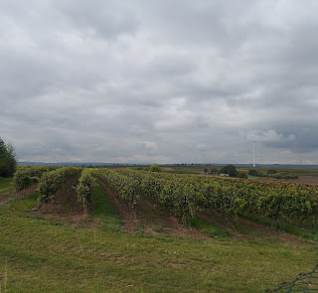

Whenever an opportunity arose to ignore the navigation system briefly (for a photo), I would do it.

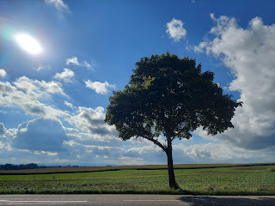

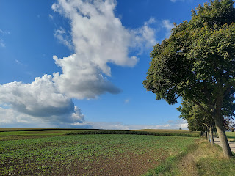

Finally I arrived back near Strasbourg, in a little settlement called Duntzenheim. This is where my Schnepp/Schnapp ancestors lived in the 1600s. (on my Dad's line)

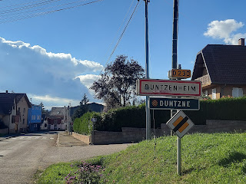

I was particularly fascinated with the old houses and their specific features.

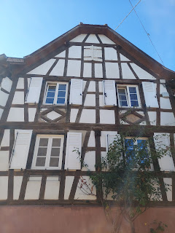

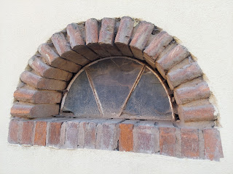

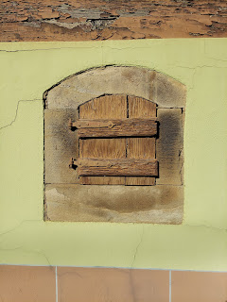

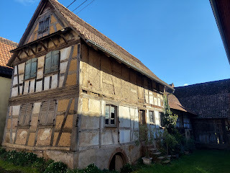

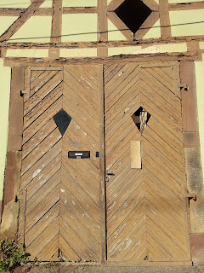

Current-day inhabitants have done a great job with making an ancient edifice livable in today's world.

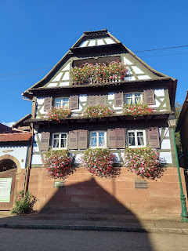

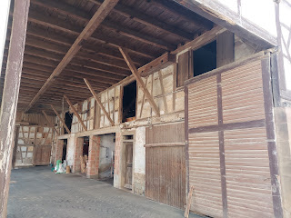

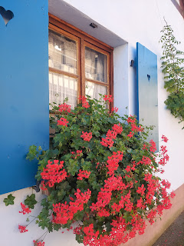

As I walked up the main street, I saw a church in the distance. And this cute building below was the equivalent of a post office and perhaps even a teensy library at the same time.

Click to watch a video while I walked toward the church: (59 seconds)

https://photos.app.goo.gl/jpXe7yLUSx1Auz9r6

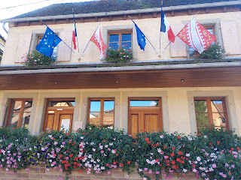

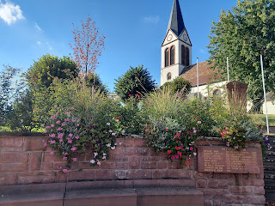

There were a couple of plaques in front, to remember the dedicated men who served in WWI and WWII from Duntzenheim. I found a couple of Schnepp names that served in WWI.

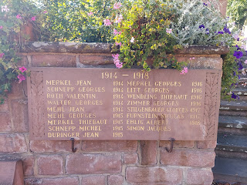

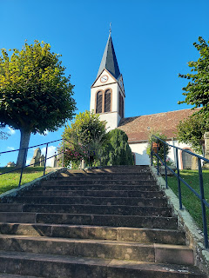

I wandered the cemetery, but didn't find any Schnepp names.

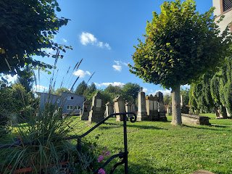

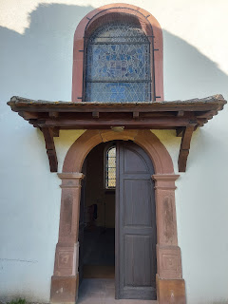

As I left the church, I struck up a conversation with the gardener, a young man - perhaps in his late 20's. He said there are a lot of Schnepps still living in Duntzenheim! He told me I should check with the lady in the post office to see if I could connect with any Schnepps still living in the area today. It was more difficult speaking to the lady inside, because she didn't understand English quite as well. But she got the gist of what I was trying to do. I offered to write down what I wanted, in the hopes that she might communicate with a Schnepp family member at some point.

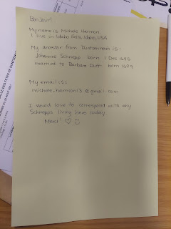

I received an email from her later that same day! She sent me a link to a magazine article written about Duntzenheim and its history. It's all in French, so I will need more time to translate it. It wouldn't let me cut and paste the words into a translation app. (!)

Here is the link:

https://www.dalsaceetdailleurs.com/2021/04/07/duntzenheim-village-protestant-du-pays-de-hanau-lichtenberg-bas-rhin/

I had come. I had conquered. Now it was time to drive back into Strasbourg and turn the car back in. What a liberating day! All my fears were put to rest when I went out on the open road. I love a beautiful scenic drive. And I had no issues crossing the border between France and Germany. Piece of cake. Or, as they say in Italy: Pizza Cake.

The navigation system took me through ALL the corn fields to get back into Strasbourg, ha ha.

Short video of my drive: (44 seconds)

https://photos.app.goo.gl/2xcqzTavpCZUJrm47

I hit rush hour as I got back into the city and it took me a full hour to just get gas and get a couple blocks over to the car rental place. As the lady there was checking everything over, she noticed on my gas station receipt that I had filled up the tank with the wrong type of gas.

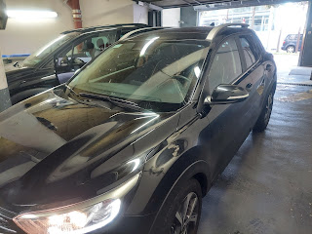

But it wasn't just a small mistake. It was an epic mistake.

First of all, nobody told me what to do. When I rented the car, they just told me to fill it up at the end, and that there is a gas station down the street. Secondly, at the gas station, I went inside to ask the man which gas should I choose because they were all color coded and I had no idea which one to use. He looked at my car and said, "The yellow one." So I chose the yellow pump.

I should have known something was wrong when the nozzle didn't fit into the hole. I trusted the man at the station, and just figured it was an oddity of France or something. I filled up the tank, paid, and left.

The lady at the car rental center said that I should have put unleaded gas in. There was a green sticker next to the gas tank, she said. But nobody had pointed that out to me. What I did instead was put DIESEL in. Whoopsie . . . Well, in France, any mistake you make is going to be costly. Any fine you receive is going to be monumental. They are perfectionists by nature, so they want you to be sure to do things correctly the next time - and that you won't ever forget the lesson you learned.

Sooooo, my fine for them to eventually drain the tank and put the correct fuel in was

390 euros

. The equivalent of

$451 US dollars

. Maybe that's why I had such a profound anxiety about going to France to begin with! Holy cannoli!! I don't know if I can get out of that fine, but I'm going to try. I'll check with the rental car insurance as well as my Visa company. If not, that will be a memorable life lesson to learn.

After I got back to my apartment, I was ready for food and then some time to unwind and relax. Thankfully, there was a nice restaurant right across the street that my host had recommended. The menu was all in French, but I used my Google Translate app to piece together what to order. I chose the Carpaccio di Manzo. It's basically thinly sliced raw beef with pesto drizzled on it, parmesan, arugula, pine nuts, and some interesting garnishes with a stem. Not sure what they were, but they were delicious.

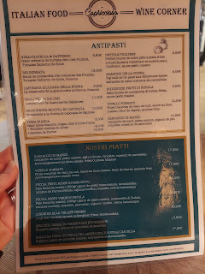

I'm pretty sure this was the fanciest thing I've ever eaten in my life.

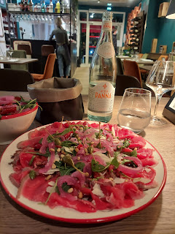

Friday:

I squeezed in one last tourist adventure before leaving Strasbourg - visiting the ancient Cathedral that I was seeing out my window every day. It was only a 6 minute walk from where I was staying.

There are many old churches and cathedrals around Strasbourg. This was just one that I saw along my way.

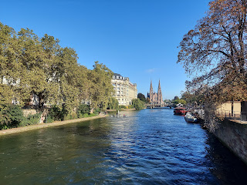

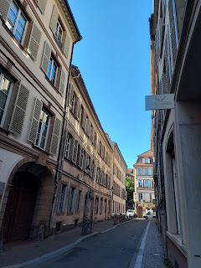

Video of me walking around the corner to the Strasbourg Cathedral: (14 seconds)

https://photos.app.goo.gl/Mya7GFz9q8JWnVR29

This Cathedral was built in 1439!! Daaaang.

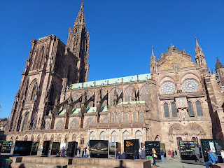

Video of the entire plaza, including the adjacent Palace: (26 seconds)

https://photos.app.goo.gl/UzuBdHXzZoGn8ku38

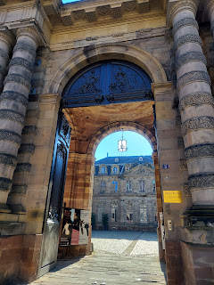

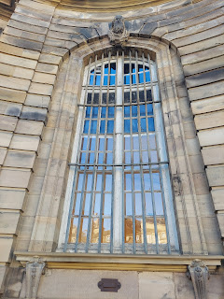

A professor was in the middle of instructing his art students about some watercolor techniques. They were painting a picture of the Cathedral while seated in the middle of the plaza. The students looked like they were college age.

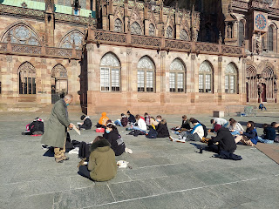

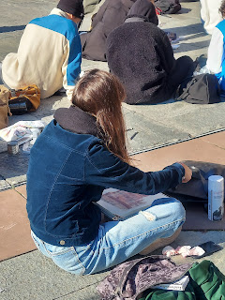

Some closer detail work on the exterior is shown here. I always marvel at how the artisans would have accomplished such beautiful handwork so long ago.

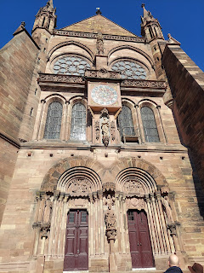

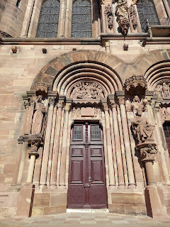

If I had more time, I would have visited the Alsatian Museum (below). It would have provided more context for the Alsace Region of France and given me more information about the time period that my ancestors lived here. But, alas, I was out of time.

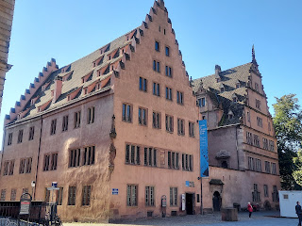

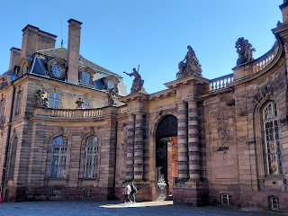

The Palace looked quite impressive, strong and protective of its inhabitants so long ago.

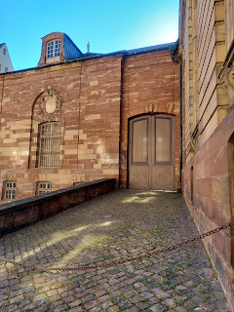

Another old church I saw on my way back to the apartment.

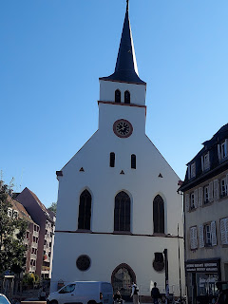

This was my host, Yeonock. She and her husband are from South Korea, and both of them speak just a little bit of English. It was so lovely to stay with them and I enjoyed visiting with them in the evenings.

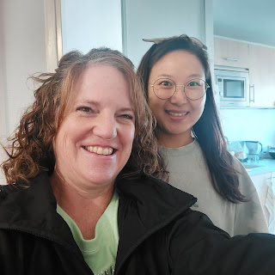

The first night, as I was meeting Yeonock's husband, he was asking what I was doing in Strasbourg, all the way from America. I told him I am doing family history. He didn't know what that was, so I tried to explain it in simple English. He was intrigued, and asked, "What is your motivation?" I told him that my church teaches us that we are all part of the family of God and that family means everything to our Father in Heaven. I like to learn about my family (my ancestors) so that when I get to heaven someday, I will have several conversation starters when I meet them there.

He wanted to hear more. So I told him about when I visited Virginia last year, and stood on the land where my ancestors lived in the 1600s. As I stood there, I felt a warm feeling in my heart, accompanied by the words that flowed into my mind, "Thank you for being here. Thank you for caring about my life."

Yeonock's husband then said to me, "I am very moved by what you say. (placing his hand on his heart) I have a feeling in here that I don't know before. Please, tell me how to know more." I taught him a little bit about FamilySearch and Ancestry, and showed him where he could find more information on Korean genealogy and the clans that have already been researched. I told him that there is a Family History Center in Strasbourg where there are people there to help him. He was very excited to learn more about his ancestors and to feel more connected to them.

I asked him about his work, what does he do? He and his wife are both opera singers!! They perform in Strasbourg at the Opera House. Wow! He is a tenor and Yeonock is a soprano. They are hoping to start a family very soon. I will be praying for them. :) They were so delightful and warm and kind. I am so grateful that I could meet them and stay in their home.

I got on the bus to head to the train station, with scheduled stops in Stuttgart and then in Moessingen. It turned out there was another unscheduled stop that wasn't on my ticket.

When I got to Tubingen, everyone started getting off. One lady indicated to me that I needed to get off as well. I'm thinking, But this isn't Moessingen! Then the train personnel man (that had checked my ticket earlier) passed by and remembered that I was going to Moessingen. He also told me that I needed to change trains. At least he spoke a little bit of English . . .

Apparently, this was the end of the line for my train, but the adjacent train was the one that would take me on to Moessingen. I got off the train with all my personal belongings, and walked over to the next train. There were many, many people slowly boarding the small train. I became very concerned that there wouldn't be any room for me! I knew the train would be closing the doors at any moment, and there wasn't even space for me to lift my suitcase up the 3 steps, let alone get in there myself! Finally, each person moved one inch at a time until there was just enough room for my suitcase and my body to get onto those 3 steps. I stood on the 2nd step, holding on for dear life, all the way to Moessingen. It was a bumpy and wild ride, ha ha. Picture an old wooden roller coaster, with you getting jostled all over and everywhere. That's what I experienced from Tubingen to Moessingen.

However, from the moment I arrived in Moessingen, I knew that all would be well. Peter, my AirBnB host, was there to greet me, holding up a sign that said "Michele" on it. He graciously took my suitcase and helped me into his Mercedes van for the drive to his house.

Right away, I spotted my first "Muller" business! Apparently Muller is a very common name in Germany, similar to the name Miller in the United States. But I didn't care! These were small towns and any family name that I spotted felt like it was mine.

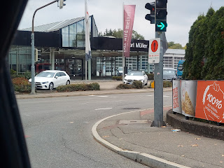

On the drive from Moessingen to Ofterdingen, just a few minutes of time, I took a few videos of us driving along so that I could share the experience with my family back home. (Especially my mother)

Video #1: (1 min, 18 sec)

https://photos.app.goo.gl/YptW2UCaJNMAZ3yk6

Video #2: (1 min, 7 sec)

https://photos.app.goo.gl/kdHp3neuWDgXVonM9

Video #3: (1 min, 1 sec)

https://photos.app.goo.gl/mYuaWWFRGh7iq7FQ8

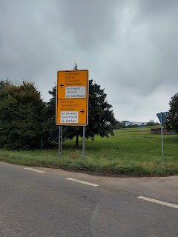

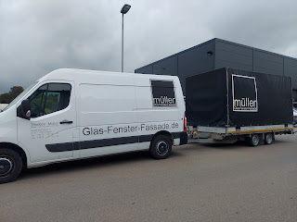

And as I walked in, it felt like this was the fanciest AirBnB I've ever stayed in! It's so modern and fashionable, with every possible detail factored in. I took a video so I could give a little "tour" of where I've been staying.

Video of the AirBnB: (2 min, 7 sec)

https://photos.app.goo.gl/YTKA9ZM9ahtjBgDt5

Short video of what it's like to watch TV in another country, in this case Germany. (33 seconds)

https://photos.app.goo.gl/ebVnYUCWPXmGxUJZ9

Even though it was in German, it was still relaxing to watch a calming nature show after a day of traveling.

After a short rest, I headed out on a walk to see what I could see in Ofterdingen. It has a nice mix of modern architecture mixed in with the old.

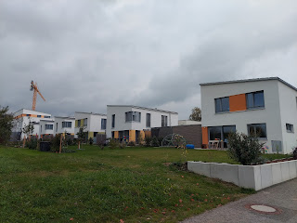

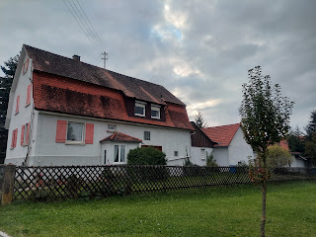

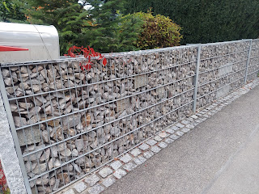

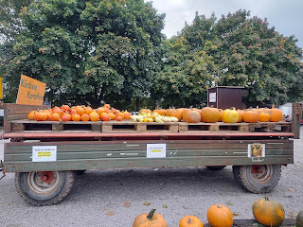

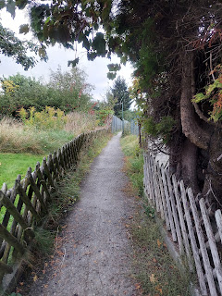

This is the old church (Kirche) in Ofterdingen. It's very possible that my ancestors worshiped here, and even got married here and baptized their children here.

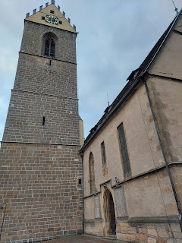

Video of me walking up to and around the church for the first time: (1 min, 41 sec)

https://photos.app.goo.gl/Z1PWMuGqZ6pKM3LW6

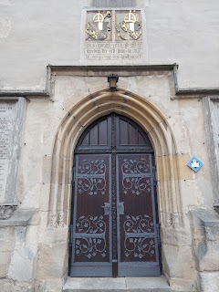

These were plaques to honor those who served (or perhaps died) from Ofterdingen in WWI. There are several Schmid family names listed here, which very likely are my relatives. My 2nd great grandmother, Maria Margaretha Schmid came from Ofterdingen, as did her parents and grandparents and many more generations.

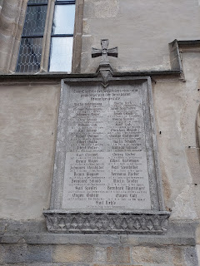

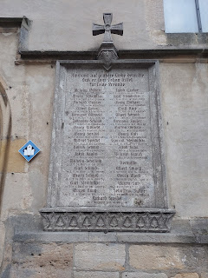

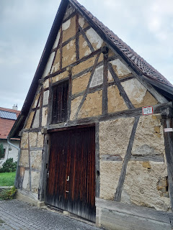

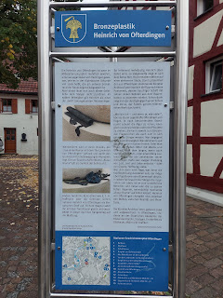

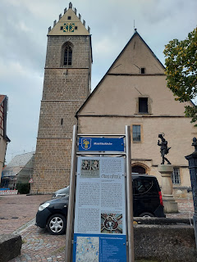

To read these signs, I have to manually type in the German text into my Google Translate app, but the little bit I learned from the photo below is that the tower is the church's oldest part, dating back to 1427. The basement was built underneath the tower at that time, with a chapel room.

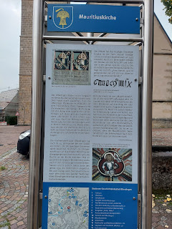

I seem to have a fascination with old doors. They have both a story to tell and a beckoning to enter.

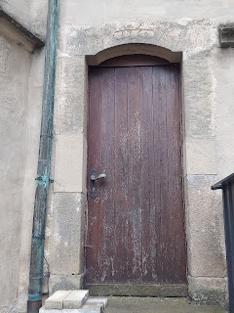

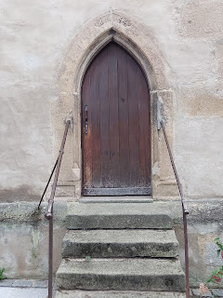

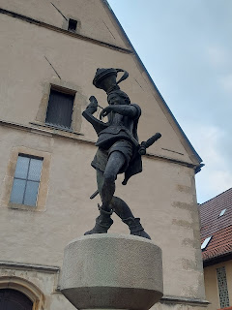

A lot of places I've seen in Europe have these fountains placed around town. The water is fresh and you can drink directly out of the fountain or fill up your water bottle. I find them to be quite charming.

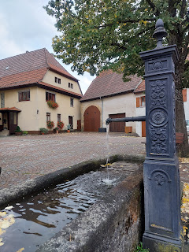

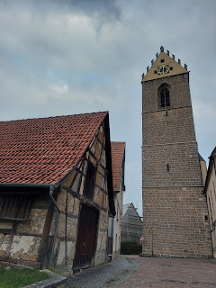

I think this next sign is talking about the church and how the neighborhood came to be.

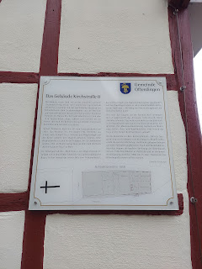

I made a trip to the nearby grocery store. Once again, it took me quite a while because I was so interested in all the products they had to offer.

Shelf stable eggs again

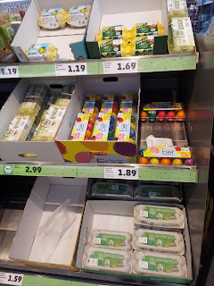

I got a kick out of the brand name: Gutfried (for a lunchmeat)

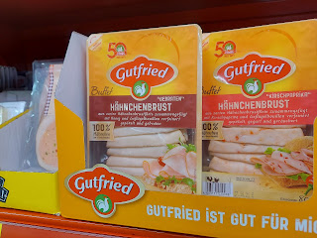

Several cheeses I've never heard of before.

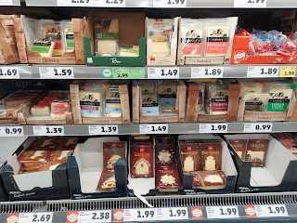

And MANY types of sausages and hot dogs.

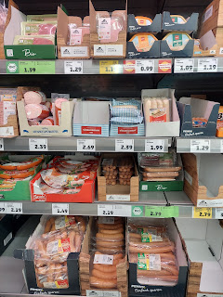

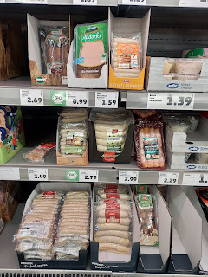

Not exactly sure what these are . . .

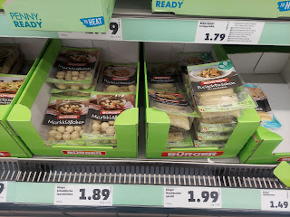

Or these . . .

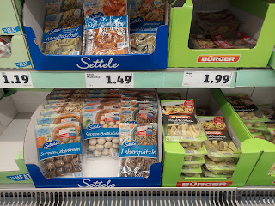

But I know what these are!!

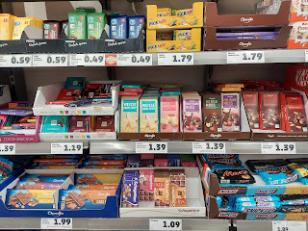

As I walked home with my loot, I was very happy. I had food. I was in a comfortable place to sleep. And I was in OFTERDINGEN!!

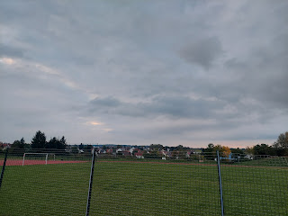

And who wouldn't love to live in a cute house like this, with pink shutters? :)

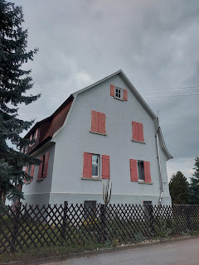

Or this house, with the beautiful wood details.

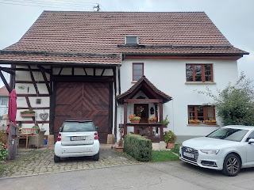

I cooked up a little dinner for myself using these ingredients:

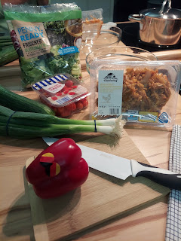

The only thing I forgot at the grocery store was some salad dressing. Oh well. It was still very good!

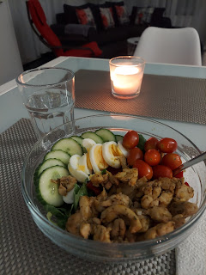

I did 2 loads of laundry and hung them all up to dry overnight. It always feels good to have clean clothes!

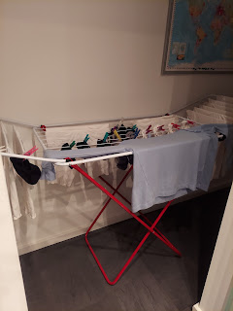

While I ate dinner, I called Amber and got all the stories about their first ever family cruise to Mexico! They went "snuba" diving (a little different than scuba diving), and fed several exotic birds in Cozumel. The girls had fun swimming and doing all the activities for kids on board. Abby got really good at mini-golf for example. And Weston's parents were able to join them on the cruise, too. :)



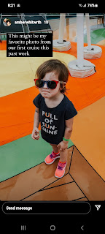

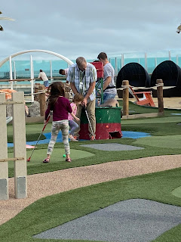

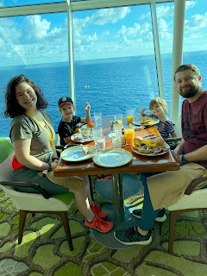



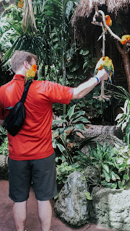

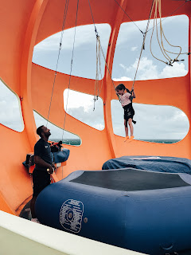

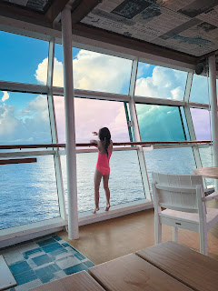

HOW FUN!!! I would love to join in with them next time!!

As we talked on the phone, I was able to connect with both Abby and Gwen this time. Abby is still on Fall Break, so she was home during the day for me to talk to her. Usually she doesn't get home until mid-afternoon, which is when I'm already in bed in this time zone.

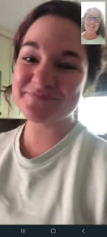

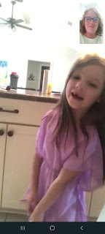

Gwen was eating ALL the oreos, ha ha.

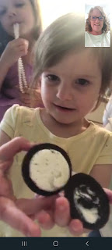

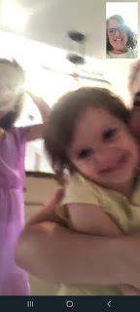

The are busy getting decorations up for Halloween in Louisiana. :)

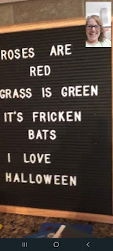

And Abby's front teeth are finally starting to come in!

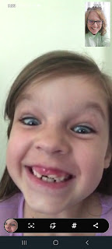

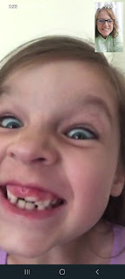

Man I miss those two little girls!!

Saturday:

After a wonderful and leisurely morning, I received a ride from my trusty host, Peter, into the center of Mossingen to meet up with a professional genealogist for the afternoon. Karin Jauch is her name, and she has been working to gather details on some of my German roots here in this area. She isn't cheap, so between my mom's budget and my own, we had to scale down the list of requests. Karin was very upfront about her fees, which includes time to translate everything into English, as well as the miles she has to drive in order to visit the church archives. We capped the budget at $500.

Yes, it sounds like a lot of money, and it is! But it's also very crucial to get the help that we needed, and when we don't speak German, our situation becomes even more desperate. Karin is able to visit the archives in the area and get copies of the original records. The things she has been able to find are remarkable - I could not find this same information on Ancestry.com. So I am very grateful indeed!

I asked Karin to focus on finding information about my 2nd great grandparents, Johannes Muller and Maria Margaretha Schmid, who immigrated to the United States in 1880. They are the grandparents of my Grandma Doris, who is still living and is 100 years old now! I also asked Karin to find information about each of their sets of parents. She offered to give me a historical tour in Mossingen as part of the package, showing me some sights that are pertinent to my German ancestors. So that is what we did!

Peter dropped me off a few minutes early at the designated meeting spot, the old Protestant Church, called "Sankt Peter und Paul". I knew right away that this church was special, but I didn't know all the details until later in the afternoon.

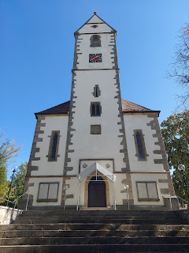

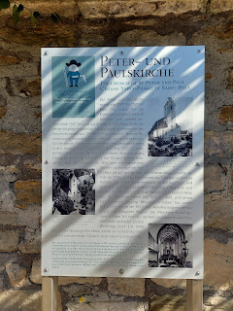

They, too, had a memorial for the soldiers who served in WWI from Mossingen. It was like the elephant in the room as I noticed there were no memorials for WWII. On these WWI memorials, I noticed several family names: Muller, Foll, Haap, Lutz, Maier, Schmid, Schanz, Streib, and Wagner.

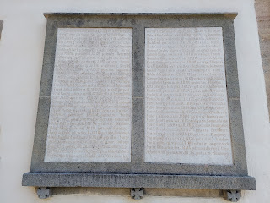

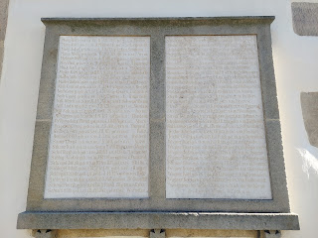

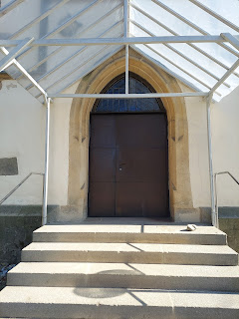

As I began my slow circle around the church, taking it all in, here came Karin around the corner from the back of the church! She said, "Ms. Harmon?" I replied with an enthusiastic Yes, and she gave me a big hug. :)

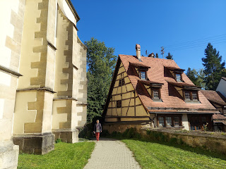

She spoke extremely good English, which I very much appreciated! We continued the slow lap around the church together.

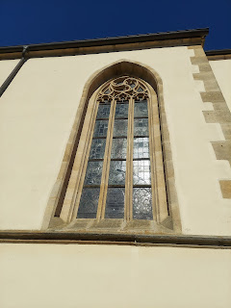

This is a portion of the remaining wall that once surrounded the church so long ago.

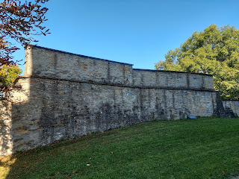

Back in those days, the church was more than just a place to worship. It was also a fortress and a safe haven in times of stress (war, fires, or other disasters). It was built up on higher ground than the nearby houses, in case the adjacent river flooded (which it has).

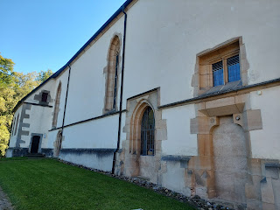

And the 3rd little keyhole window (from the bottom) was used to defend the fortress, if necessary, by poking a musket out through the slender opening.

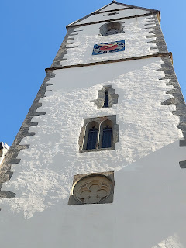

A historical nugget from the internet:

The Peter and Paul Church is the oldest church in Mössingen.

In 789, a church is mentioned for the first time on the site of today's church - even then with the current name.

The current church was built between 1517 and 1527.

The lower part of the church tower, however, is much older and dates from 1367.

The 39 meter high church tower used to be part of a defense and signal system.

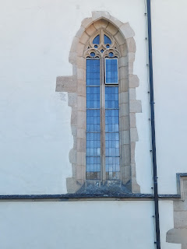

Karin pointed out to me that the cornerstones seen here were important to reinforce the strength of the overall structure when it was being built. They also indicate the antiquity of the edifice.

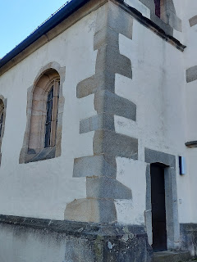

Someone left a little gift at the side door using chestnuts from the trees in the gardens.

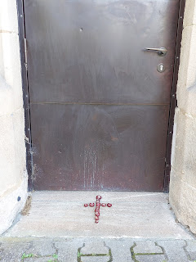

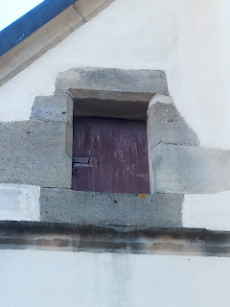

I also learned that when you see a house such as this one, directly across from the front door of the church, you can tell that it is OLD when you see how each new level juts out as they built up the structure. This was smart engineering back in those days, to be sure that the base underneath would continue to hold.

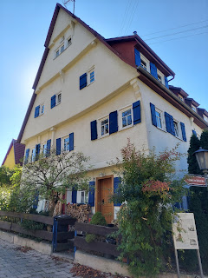

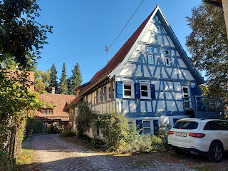

I just loved this cute little house next to the church (below). It makes me think of Hansel and Gretel for some reason, ha ha.

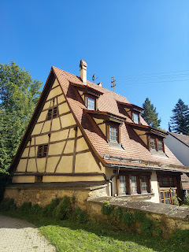

Behind the church is the cemetery. Similar to Switzerland, they don't keep the old graves very long. So most of what you see is within the last 25 years or so. It is still possible that my ancestors are buried here, further down, but they might also be closer to the church, perhaps near the ancient wall on the side.

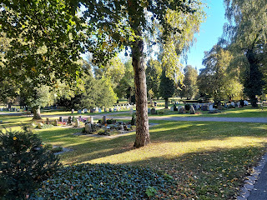

Again, I saw familiar names sprinkled around: Wagner, Muller, Schanz, and Haap.

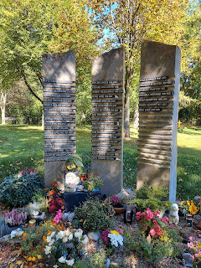

It was all very beautiful and park-like.

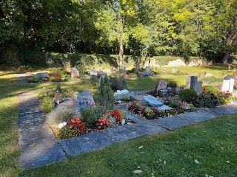

Next, we walked around town, stopping occasionally to discuss an older feature or sign.

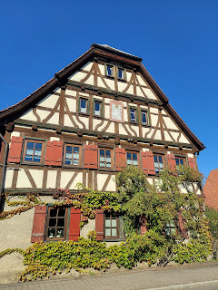

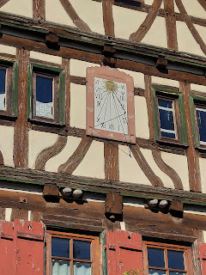

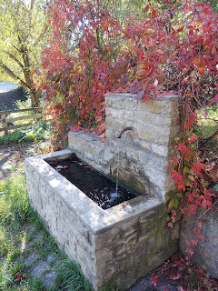

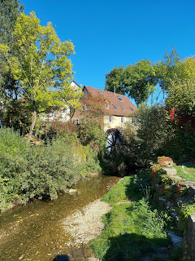

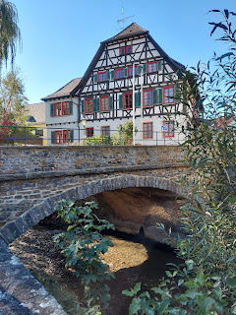

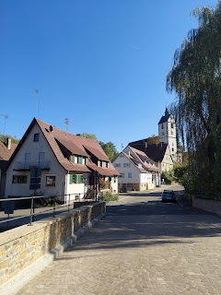

If you look closely, they typically include a small paragraph in English on the signs.

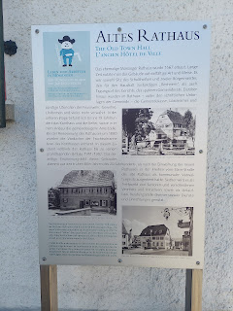

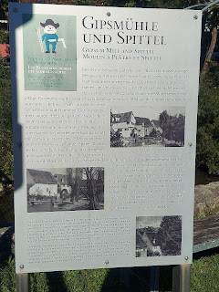

In Mossingen, which is in a valley next to the Swabian Alps, they have up to 1,000 varieties of apples that they grow here!!

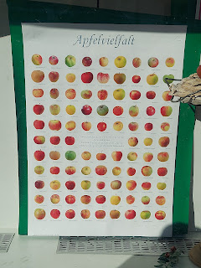

I enjoyed the storefronts. This wedding dress was made by a local seamstress and made for one specific bride. :)

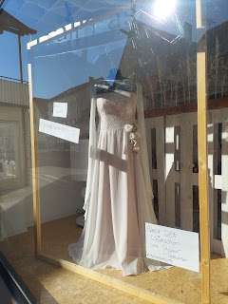

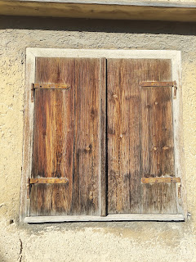

This shows a listing for a local apartment for rent. Things over here are quite expensive!

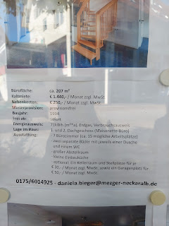

More photos of the apartment and what it entails.

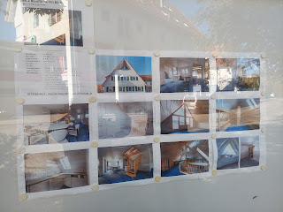

There is a little river that runs through town, the same one that is next to the old church.

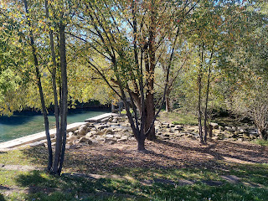

They made a little pond with a dam that they can control if there is worry of any flooding.

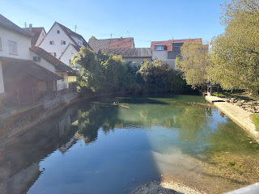

And this sign was cute, with a sing-song sort of poem, giving thanks for all things in the autumn harvest season.

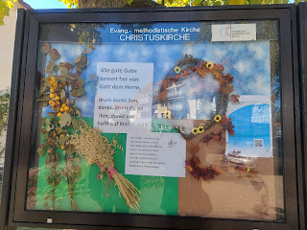

At the end of our tour through town, we arrived next to this old-but-renovated factory. It is called Pausa (pronounced Powsa). Long ago, it used to be a huge factory for linen weaving and textile manufacturing. Later it became vacant and was an eyesore, but the town decided to refurbish it. Today it houses the local library and other community resources. What a blessing that must be, and what a great decision to freshen things up instead of bulldozing it down!

I think Karin chose a cafe next to the old weaving factory for a good reason . . . (more on that in a minute)

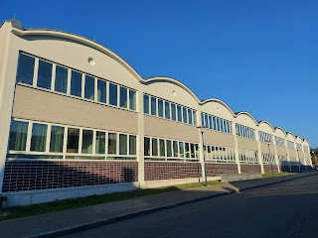

She encouraged me to try some of the fall foods that are unique to this area, such as the fresh apple cider and onion cake!! First, she had to ask the waitress in German if the cider was very fresh or not, because if it's not super fresh, then it becomes alcoholic. Yikes, ha ha. As it turned out, it was not alcoholic and thereby safe for me to drink. :)

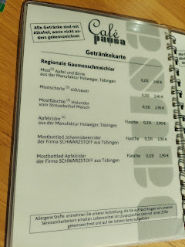

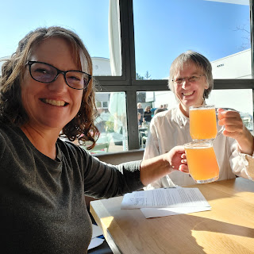

The onion cake was amazing! It was more like a quiche - very light and spongy, with egg and a bottom crust. It had chopped cooked onions all throughout, and it was nice and warm.

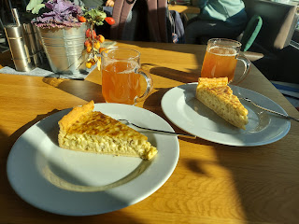

In the cafe, they also sold some local varieties of apples. Note their German names. :)

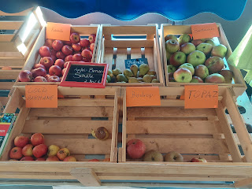

Now it was time to do business. Karin produced all the information that she had painstakingly put together these past few weeks. I learned several new things:

Several of my ancestors were weavers, one was even listed as a hosiery weaver

Weavers typically had horrible working conditions. Because the textile they were working with was so delicate, they had to work long hours in a basement away from any light. There was no fresh air and the room was damp. Because of this, many weavers tended to have shorter life spans.

In the case of the weavers in my family, I only noticed 1-2 people who died quite young

My 2nd great grandmother, Maria Margaretha Schmid, had a different set of grandparents than I had ever seen before. Karin said that Schmid and Muller are such common names that it would be easy to make a mistake. She chooses to only work from church records as she builds a family grouping, because the records are so full of information and it is easy to establish a pattern and to be sure you have the right parents.

In the church records here, it even lists the time of day that each new baby was born!! I saw that one of my ancestors was born at half past 5 o'clock in the morning. Wow.

A huge surprise: my 2nd great grandfather, Johannes Muller, that we knew to be our immigrant ancestor - well, he was not the first one!! His father, Bernard Muller, was over in the U.S. prior to Johannes. And Maria's brother was in the U.S. as well.

Bernard Muller, my 3rd great grandfather, did not die in Germany as I have always thought. He died in OHIO!! And he died in a tragic train accident in 1878.

I went into Newspapers.com to track down the story last night. Here's what I found.

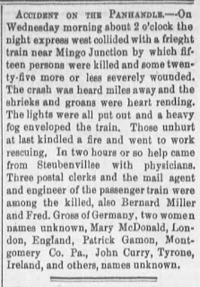

I don't know if he was coming or going to the Muller Family Farm in Bradford, Ohio (on the other side of the state from where the accident occurred). But he died in 1878. Johannes didn't immigrate to the U.S. until 1880. Verrrry interesting!!

There were many things that I learned, and am still discovering. I am very grateful that Karin is meticulous in her work, that she speaks English, and that she is willing to continue to help me discover more (as I am able to pay her of course). LOL

Eventually we parted ways and I decided to walk back to where we began.

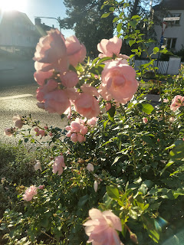

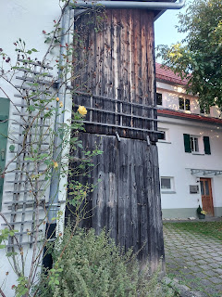

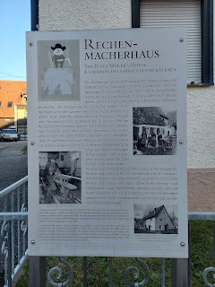

Video of me walking around the corner to the church one last time: (20 seconds)

https://photos.app.goo.gl/8964oDgqiYPmieTg8

Now I had more context about what the significance of this church truly was. Johannes and Maria were married here!! (1876) On this very day!! (October 10th) Happy Anniversary you two!! :)

Their children were also baptized here, and many other family members as well.

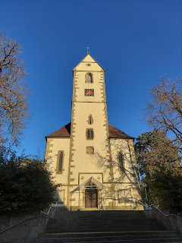

While I waited for Peter to come back to pick me up, I was able to connect with my sister Charmaine briefly on a video call. I wanted to share a live tour of the church grounds with someone! It was pretty special to be able to share that with her.

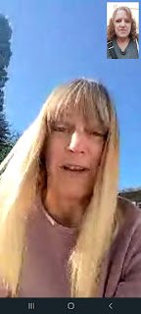

Just as Peter pulled up and I said goodbye to Charmaine, I noticed this tiny little heart-shaped leaf on the steps in front of the church. I'd like to think it was left as a gift by my ancestors, perhaps, as their way of thanking me for coming. 💓

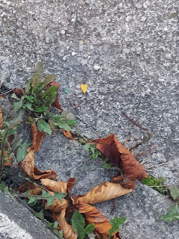

Sunday:

On Saturday, I was able to connect with the Bishop of the closest ward here in Germany and we made arrangements for me to have a ride to church. This super cute older couple came to pick me up: Heidi and Klaus Widmann. (She told me they are both 72, have 5 daughters and 14 grandchildren.)

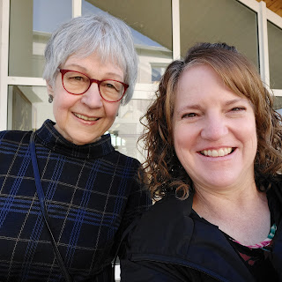

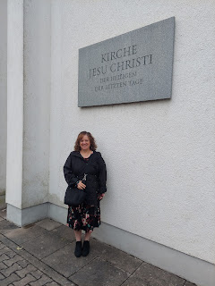

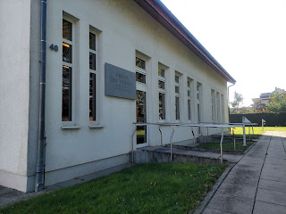

Their ward usually has 100 attendees, but they are restricted to no more than 70 in the building at any point. Masks are mandatory, and they are diligent about cleaning the podium and microphone in between each speaker. Many of the members just watch the services at home on Zoom. They have 4 full-time missionaries (2 elders and 2 sisters) who were right there in the foyer to greet me when I arrived! Three of them are from Utah, and one is from Oregon. They help to translate the services into English (not sure if any other language).

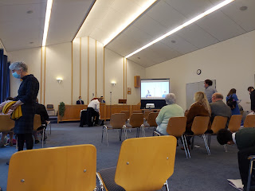

At the encouraging of Heidi, who said everyone would love to hear what I'm doing here, I got up mid-way through the meeting to share my testimony.  The Bishop whispered to me before I began that he would translate whatever I said into German, and asked me to please speak slowly if possible.

I spoke slowly in English, and would pause periodically so the Bishop could translate. He spoke into a separate microphone. Even though it was slow going, it was still very meaningful, at least to me. I shared my love for family history and how, through God's eyes, we are all part of one great Family. I told them about Yeonock and her husband and how they felt something special about the purpose of family history. I had a lot more I would have loved to say, but it was somewhat tedious to wait for each phrase to be translated, so I kept it short and sweet. :)

A couple minutes later, a lady (on Zoom) started talking and sharing her testimony of the gospel. Heidi leaned over and began whispering an English translation of everything the lady was saying. Apparently, what I had said made an impact on her, and she wanted to be more diligent in learning about her ancestors and making sure their temple work was being done.

A few people came up to me after the meeting was done to visit with me. One of them spoke perfect English! It's because she is originally from San Diego, ha ha. She and her husband moved over to Germany for work reasons, and they've been here for 2 years now. At first they were pretty homesick, but now they love it a lot. Another lady said in very good English that her son went to Rexburg, Idaho to attend BYU-Idaho. He met an American girl there, got married, and now they live in Utah! She (the German mom) wants to go visit them, but there are strict rules against people from the Schengen Area of Europe traveling to America right now. She is hopeful that next year they can go to the U.S. for a nice visit.

The highlight of going to church today was being able to (attempt to) sing in German. Heidi shared her phone screen with the words of the hymns in German for me. I got choked up so many times! Not only does singing in German while in Germany help me to feel connected to my German roots, but I felt something even more profound. I felt like my German ancestors were so proud of me, and I felt their love as I sang. I felt like they were happy that I was in their home town, in a nearby church, and singing in their native tongue. It was an elevating and special feeling. One that I will NEVER FORGET.

As Heidi and Klaus drove me back to my house here in Ofterdingen, Heidi gave me a plate of cakes that she had made.

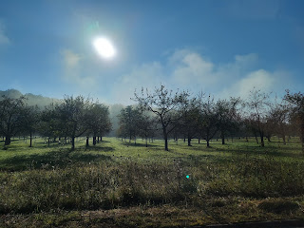

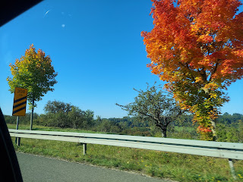

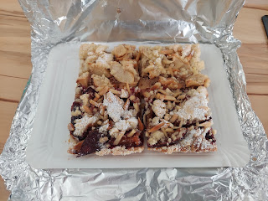

There are two pieces with maybe a sliced plum on top? And two with sliced apples. I ate a piece with the plum on it and it was very tasty! Heidi and Klaus also came back over later in the day to bring me some additional gifts. They brought me a book about the area here, and a cute little tin full of cookies that Klaus had made himself!  I wish I had gotten a picture of him, he is just the cutest! He always seems to have a little twinkle in his eyes. :)

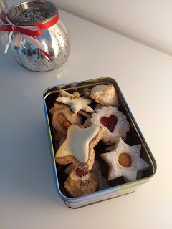

Lastly, I have a whole bunch of Jack for everyone to enjoy. You're welcome. :)

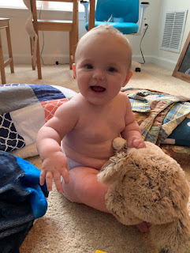

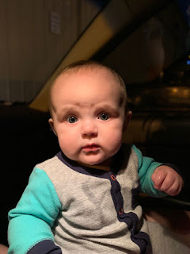

And some videos for y'all. He is practicing sitting up by himself lately and is doing a great job!

Video #1: (25 seconds)

https://photos.app.goo.gl/Ki1MWMmBta6QZkHG6

Video #2: (19 seconds)

https://photos.app.goo.gl/D3uuqLqaz2NZm2UX9

Video #3: (36 seconds)

https://photos.app.goo.gl/pu1tqnqUy2pk6dFV8

What a tremendous week it has been. Mostly highs, a $450 low, and then all the way back up again. While it is mentally exhausting to be on top of so many details every single day, saying my prayers and getting adequate sleep are my lifelines. This is what I have wanted to do for so long! I have not come this far, only to come this far. :)